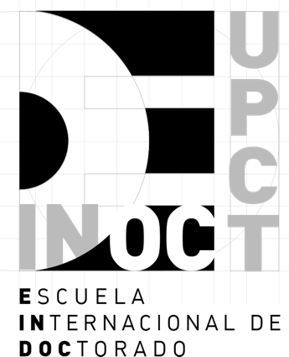

CO-SUPERVISION APPLICATION FOR STUDENTS FROM OTHER UNIVERSITIES WHO WANT TO DO A FELLOWSHIP AT UPCT

PERSONAL INFORMATION
Last name: |  | Name:
NIF/ Passport: | Nationality:
Place of birth and date of birth:
Address:
Municipality: | C. Postal: |  | Province:
Country: | Phone: |  | E-mail for notifications

ACADEMIC DATA (fill in all that apply)
Entrance qualification and year obtained:
Issued by the University / Higher Education Center of (name, city and country):
Doctoral studies (start date, University and Country):
UPCT Doctoral Program for which recognition of foreign studies is requested
Forecast reading date

DOCTORAL THESIS
Thesis Title: |  |  | Writing language
Thesis Directors: | For the UPCT, | MR./MS.
 | For the other University | MR./MRS.
The Reading and Defense of the Thesis will take place at the University:
Applicant's signature
In accordance with the provisions of current legislation on personal data protection applicable to the Polytechnic University of Cartagena (hereinafter UPCT) and published in the search engine UPCTlex regulations (https://lex.upct.es/) within the thematic area Data Protection, you are informed that the processing of your personal data provided in this document input or output, as well as those contained in the documentation that may accompany it, is carried out by the UPCT, with CIF Q8050013E and tax domicile in the Plaza del Cronista Isidoro Valverde s/n - Edificio Rectorado - 30202 Cartagena, with the purpose of managing and making the registry entries of incoming and outgoing requests, writings or communications received or sent between citizens and the University or between the University and other public administrations, as well as to attend and manage the requests, claims, allegations and appeals submitted.
You can exercise your general rights of access, rectification, cancellation, opposition, limitation and portability by means of a written communication and attaching a photocopy of your ID card, addressed to the Data Protection Delegate and presented either at the General Registry, at the same address of the UPCT's fiscal address, or through the Electronic Registry accessible at the UPCT's Electronic Headquarters, https://sede.upct.es.
You can consult additional and detailed information about Data Protection, your rights and the UPCT Privacy Policy at the link https://privacidad.upct.es where you can also consult extended information about this treatment under the name General Register of input and output.
For any consultation on the treatment of personal data carried out by the UPCT, in addition to the Electronic Register, already mentioned, you can send an e-mail to the address dpd@upct.es.

DOCUMENTS ACCOMPANYING THE APPLICATION FOR THE LEVEL CHECK
Copy of Passport/NIE
Copy of the title whose verification is requested, duly legalized.
Original of the academic certification of the studies carried out by the applicant to obtain the degree whose verification is requested, stating, among other things, the official duration, in academic years, of the program of studies followed, the subjects taken, the time load of each one of them and their grades.
Original of the certificate issued by the University of origin stating that the degree obtained qualifies, in the country issuing the degree, for access to doctoral studies.
Letter or document from the university indicating that the student is enrolled in a doctoral program and the date of commencement of doctoral studies at the home university.
Letter of acceptance of the Co-directorship from the thesis director at the home university.
Letter of acceptance of the Co-directorship from the thesis director at UPCT, with the approval of the academic committee of the doctoral program.
Proposal of agreement in the event that the University of origin wishes to propose a different model to that of the UPCT.

Original documents in Spanish, English or French may be submitted without the need for translation. The rest of the languages must come with their corresponding translation into Spanish.

Document requirements:
- The documentation referred to must be duly legalized.
- Foreign documents must be official and issued by the competent authorities, in accordance with the legal system of the country in question. In addition, they must be legalized through diplomatic channels or, if applicable, by means of the apostille of the Hague Convention (except those issued by the authorities of the authorities of the Member States of the European Union or signatories of the Agreement on the European Economic Area). They must be accompanied, where appropriate, by the corresponding official translation into Spanish, which may be made:
-By a Sworn Translator, duly authorized or registered in Spain, who must appear on the list of Sworn Translators-Interpreters appointed by the Ministry of Foreign Affairs and Cooperation, which can be found at the following link: Sworn Translators - Interpreters (exteriores.gob.es)
-By any diplomatic or consular representation of the Spanish State abroad.
-By the diplomatic or consular representation in Spain of the country of which the applicant is a citizen or, if applicable, of the country of origin of the document.

